**A WALK DOWN MEMORY LANE**

A Quote:

"Men can make machines that remember, but no machine gets the joy of remembering that man does himself. It is his memories indeed that largely make a man. They are food for his mind, fuel to his spirit. They resurrect his past and are his chief sanctuary from muffling oblivion. No yesterday is dead as long as it is remembered. Our album of memories is extensive if we can look back and remember. . . small everyday events of our childhood, the impact they had on our later life."

Perhaps the remembering of some of these events that old acquaintances have written about their days spent in Dyer, almost 70 years ago for some, will take you back in the rush of your busy life. Many of you have scattered to the four corners of the earth but hope those of you who have the opportunity to read these will enjoy and share these events.

**DO YOU REMEMBER?**

The Hurd Branch where many of us learned to swim, had cookouts, and learned to eat fried crawdad tails and wild onions?

The fish fries on the Old Dyer Lake?

The Daily Ditch where the boys had to take a plunge on April 1st?

No. 103 and 104 that ran through Dyer daily and the gathering at the depot on Sundays to see who arrived and who went away?

Playing hooky from school and how scared you were to return to school the next morning? But usually the worst punishment was to come later when the parents found out about it.

Rainy afternoons when Dora Moss would say, "Boys, bring in a load of stove wood, and I'll make a batch of tea cakes?"

Some rememberings are sad: How the eight grade kept flowers on Davidson Selby's desk for the rest of the year after his death?

Students were told to try out for contests in races, spelling, etc, and how in racing Myrtle Cupp would leap off and was at the finish line waiting for the others to get there?

Contest at Oak Grove School when George Weese, Tom J. Moss, Dudley Selby, and Earl Cottrell ran the relay and won?

How happy we were when the weather was cold enough for the ponds to freeze over so we could skate, and sometimes the ice broke, and sometimes someone had to be hauled out of the icy waters?

The snow ball fights at school? One could tell how much a boy liked you by the number of snowballs he threw at you.

The ciphering matches? And I could usually turn down most if I could select and make it addition, but I met my match in Otis Cottrell for he would take division, and he would beat me there.

**A WALK DOWN MEMORY LANE (cont)**

Learning to march to the "Tum-Tum" of the drum at school and "woe" to you if you got out of step.

And the wonderful water fountain built on the West side of the school.

How thrilled you were if you were asked to be in a school play?

On way home from school stopping by the telephone exchange building and holding hands as Jow Jeans touched the wires that gave us a "Shock."

How about the time spent in front of the Blacksmith shop, watching the shoeing of horses or fanning the fire in the forge?

Most of the boys are no more with us who spent many. hours listening to Dad Stephens spin his yarns.

A very seldom treat was to see a movie, afterwards to buy a DIME hamburger which was a "REAL" hamburger with all the trimmings. Imagine!

A custom in most families after supper was to take the old popcorn popper from beside the chimney and pop a few poppers of corn. Recall one at our home and Shelton Chastain and Garland Ayres were there. Mother made popcorn balls and of course we had it all over our faces. Hilda said to Garland, "Dock, you'll have to wash your face before you go to bed."

When Horatio Alders and Tom Swift books were the popular reading for young boys, while girls read Elsie Dinsmore books and "Sweet Girl Graduate."

Many a boy risked the danger of falling and being caught, just to climb on the store roof to get a peek in the Lodge Hall window, hoping to get a glance of someone riding the "Goat" or seeing "Old Jerry."

When we didn't know what the word Pornography meant. Guess the nearest was to look at women's underwear displayed in the Sears Catalogue. Can you recall how you would turn your head, especially if accompanied by a young man, when passing a window display of underwear?

Some may recall a certain Halloween: The boys had been on a Opossum hunt and later a certain mother prepared a big pot of soup for them to eat before they went on their "pranks" round of tipping over "privies" and removing front gates. While eating the soup one of the children spoke up and said, "Mother put a rooster in that soup," and Cabol Rhodes pushed back his plate because his mother had made him carry away a dead chicken that afternoon.

This incident goes way back on Halloween: There was a small platform on top of the old frame building. Some of the boys took a cow up the stairs inside and tied her up there; and Dan Chitwood called his cow next morning and finally heard a Moo high up, and there she was on the school building. Milk was high that morning.

The time the teacher punished Arlis Renfroe by putting him under her desk. He went to sleep and the teacher forgot about him. When he awoke, the school was locked. About midnight Dan Chitwood heard someone crying, and, when he went to the school, there sat Arlis in the down stairs window.

**A WALK DOWN MEMORY LANE (cont)**

**Saturday Night Baths**: This was a big family event since those were the days of no bathrooms in Dyer. A big fire was built in the cook stove to heat the room, and heat the water for everyone's bath. The big #3 tub was brought in and placed in front of the open oven door. Usually, the mother bathed the small children first. Then came the older children who could bath themselves. After the bath clean "**Long** **Handles**" were donned. The tub was emptied by the next bather because the other bather would get too cold. Night gowns, even the boys, wore those, were put on and the girls wore a night cap. Prayers and "Good Nights" were said and off to bed. This cleaning was sufficient until the next Saturday night.



The long black ribbed stockings that both boys and girls wore except for special occasions when the girls wore white stockings.

**Games**: Indoors: Authors, Old Maid, Flinch, Dominoes, Checkers, Rook. Outdoors: Skinny or Kick the Can, Croquet, Baseball, Hide and Go Seek, Anti-Over.

The old Coal heater or fireplace was so nice when one came in from school on a cold rainy day or, when it had snowed, to thaw out before while eating a fried pie or a baked sweet potato. If family used a fireplace and while you warmed one side, the other nearly froze. This is a far cry from Central Heating today.

**Washday**: This happening would take most of the day. The father or boys filled the old black washpot; while the family ate breakfast, the water would warm. Three tubs had also to be filled with cold water and warm water from the washpot would be added to make a warm water to start the washing in. Clothes were sorted in different type of washing such as all whites together, or those to be boiled, or not. A fire was kept burning under the washpot so clothes would boil. Then one had to scrub the dirt out of the clothes on a rub board. Lye soap or P and G soap was used. When clothes had boiled they were taken out of pot and put in a tub and washed again, then rinsed and "blued" and perhaps starched, hung on the clothes line to flap in the wind and sun until dry.

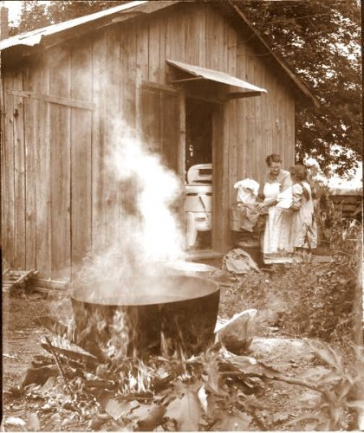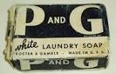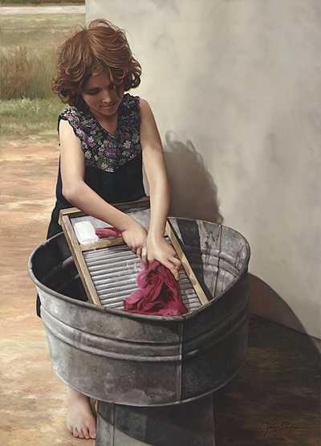

**Ironing** **Day**: This was another big chore. Clothes were sprinkled, and layed (set) awhile to make easier ironing. Irons were heated on the stove or in front of coals in the fireplace. We had a Gasoline iron so I didn't know much about "Sad Irons" And today we all have electric irons or clothing that needs no ironing.

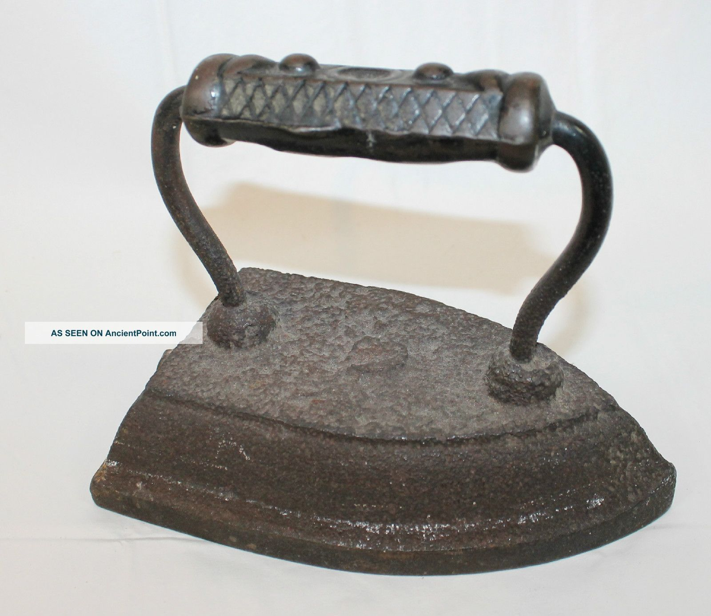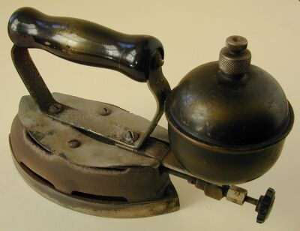

A. N. Jeans, a local Baptist minister, "tied the knot" for many couples in Dyer who decided that "Two could live cheaper than one."

Stopping at the blacksmith shop to watch horses being shod or at the grist mill to watch corn being ground into meal.

**Chivaree:** " A quaint custom where the "newlyweds were the guest of honor." The young people of the community went to their home and took the Groom for a "broomstick ride" or a "ducking in a pond." The Bride was given a wheelbarrow ride. Usually the newlyweds were prepared with "Goodies" to treat the Charivari-ers.

House raisings, Corn Huskings, Log Rollings, Quilting Bees were all reason for a get together for the Community as well as to get the work done. The quilting bees was one place where one gathered the "Gossip."

The five cent Saturday Evening Post, Woman's World, Needlecraft, and almost every household subscribed to the Comfort at .25 cents a year.



When one could trade an egg to the merchant for a large sack of candy?

When walking was the only way of traveling, except in a wagon, and the church goers carried a lantern to light their way back home as there were no electric lights in those days.

The one piece bathing suit with a skirt and short sleeves and girls wore stockings.

At school with Miss Vesta Furlow as teacher we soon learned to say, "May I" instead of "Can I". If you asked her if you could write on the board, like this, "Can I write on the Board," her reply would be, "Yes, you may if you can."

When the length of the skirt was up to your knees. Some wore "Hip" pockets on the back of the skirt. When you had your hair bobbed?

The ash hopper at the back of the house where ashes were stored to make lye soap.

**Hog Killing Time:** A cold morning arrived and this job was tackled. Killing the hogs and dipping them in hot water so the hair could be removed. Then they were hung on a pole and dressed, and children would be waiting for the bladder to blow up and play with.

When we had oranges only at Christmas time.

Buying school books at T. J. James's store and asking Mr. Marcet Bennett to write our names in the book because he wrote a pretty hand. I have a speller that he wrote my name in for me.

**Sorghum** **Making** **Time:** Going to Green Stephen's sorghum mill and, after watching the makings, he would give you a pan of "Skimmings" to eat.

**Burma SHAVE SIGNS**. Rome James could quote all of them.

When merchants kept pickles in a large barrel and crackers in a barrel or box and it was alright for one to reach in and get a pickle or cracker.

Buck Davidson painted the stove belly red, and the men would come in shivering and back up to the stove thinking they would soon be warm.

Jeremiah Eichelbarger "**witching**" for water: he used a forked peach tree limb and walked holding the limb until the intensity of the pull on the limb determined how strong was the stream of water and how many feet down to the water by the nods of the stick while being held.

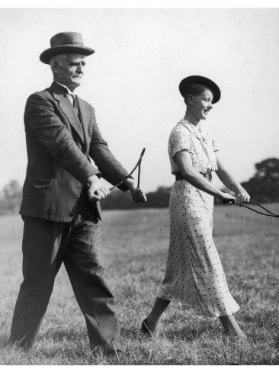

***[Editor's Note: These images above have been added to the original document compiled by Alma Lorena Moss Lancaster.]***

**Itinerate Photographer Came to town**: He traveled from town to town with that funny little black box on legs with a black piece of cloth that he stuck his head under when he snapped the picture. He usually came one day making appointment to come back the next day and get a picture of the family. We are grateful for this service or we wouldn't have family photographs of our families in days past.

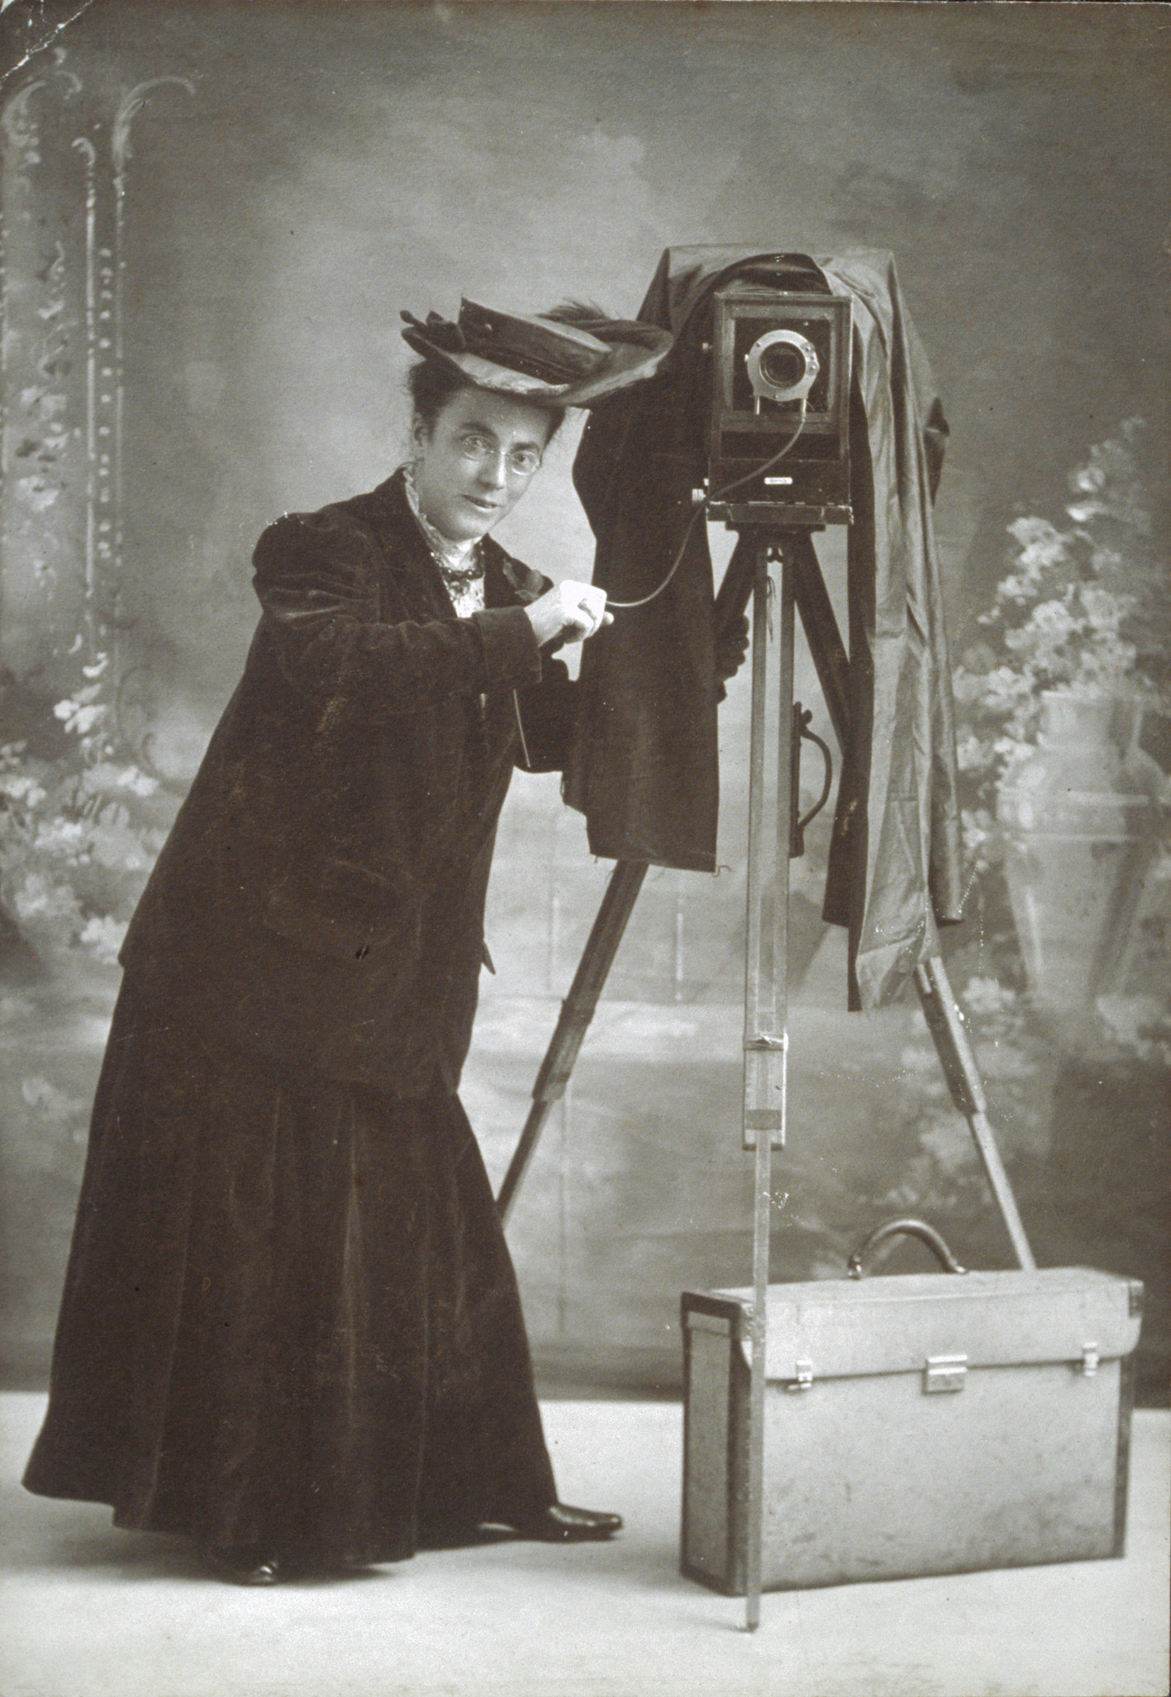

Another highlight was when the **Peddlers** came around in their horse drawn wagons and all their "wares" of cloth, ribbons, laces, and etc, inside and pots and pans hanging on the outside. This was a treat, better than looking at the Sears Roebuck Catalogue and wishing.

Speaking of **Sears Catalog**, remember when one had to pay a dollar to get a catalog? But many a hour was spent in "Wishing" from its pages. Yes, it usually finished its usefulness out in the little house down the back path.

**Rain barrel?** There was one in everyone's back yard under the roof drip where it could be filled with rain water. This was saved to do special washing, shampoos, and the like. But as children we probably thought that it was for the sole purpose of us "yelling" down in it. Remember? This probably brings back the memory of an old song about the two little girls who played together in the apple tree, yelling down the rain barrel and sliding down the cellar door. They had a quarrel and one of them told the other, "Now you can't holler down my rain barrel. You can't climb my apple tree. You can't slide down my cellar door because I don't like you anymore."

**When The Circus Came To Town?** In early 1900s the big top would come to town. There would be excitement of looking at the posters for days before their arrival. Everyone would be on hand the day the train came into town with the circus. Watching them unload the animals, tents, etc. The older boys would be anxious to get a job helping with unloading, taking the elephants to the Hurd branch for water to give them, a pass to all the wonders on the inside of the tent. Usually the morning of the show there would be a parade of animals, clowns, and all. Seemed wonderful then. And the "High Diver" jumping from a tall ladder into a tank of water. Probably wasn't that tall, just seemed so to us. Some boys who were not able to get a job would slip under the tent, and some would get caught.

**Davidson Store Promotion Sales?** Running contest and lucky winner getting a kitchen cabinet. Points given for bringing in the most Sears catalogues, black cats. Tying a dollar bill to the leg of a chicken and turning it loose; once it flew to the top of the store. Turning loose a greased pig.

Passing Mrs. Yates house and smelling her fresh home baked bread?

**I remember**: Rudolf Burrough and Robert Moss were good friends. On one occasion Rudolph was visiting Bob. Mother gave them two slices of cake, and happened one slice was larger than the other. Bob was looking at the cake, trying to decide if he wanted to be polite or take the big slice. Rudolph fixed that by saying, "Robert, I am company, and you always give company the larger piece."

Van Burrough and Tom Moss were ball players. They nicknamed their brothers who were very small, Ty and Ty Cobb. The names stuck until they were big kids.

One Christmas' Santa left Tom a **Magic Lantern**. Neighbor boys would come over to see the movie which was about two little boys fighting, and as I remember, I don't think it had much action.

**Do You Remember:** The Medicine Shows that came to town? Gypsies, and merchants running to lock their stores before they could enter stores?

The Dave Cottrell house was always open to us to have a party?

Taffy pull and peanut brittle making?

Jumping in a big feather bed on a cold winter night?

When yards had no grass. In fact, they were scrapped with a hoe.

**BONNIE WEESE REMEMBERS**

**Some Halloween pranks**: One year when cane was grown here and it was loaded into box cars and hauled away. Someone used the crane that was used for the lifting of cane to lift a wagon and put it upon Henry Burrough's store.

Another instant was after the Lodges had disbanded, someone broke into the Lodge Hall and took out the Regalia and strung it up and down the street; also put "Old Jerry" out there too.

One Halloween the boys moved a "privy" up to town and placed it besides Thomas Moss's store, took the sign from his store "The Economy Cash Store" and placed it as a caption on the privy. They got no fun out of Thomas Moss as he went about his business and didn't even get his sign; then one morning he went up to town, and the sign had been replaced on his store.

**JOHN PAUL WARRICK REMEMBERS**

I remember the first Ford cars. My father, Charley Warrick, got a car in 1917. His first car was a 1914 Chevrolet, and when he went through the Hurd Branch, it would drown out, so he sold it to Jess Chastain.

Also recalls that just outside the City Limits there was a sign on the telephone pole which read, "Travel at 15 miles an hour and close your cut out." Once, when riding with his father, he told him that he had failed to close his cut out, and Mr. Charley replied, "Well, your grandfather John Warrick is mayor, so maybe we can get by with it this time."

His father had told him about this incident. A shipment of 3 barrels of cider came into the to the railroad station. Some of the boys figured out that they could bore a hole through the floor in the storage room at the depot where it was stored, and into the barrels, which they did, and someone was minus their cider.

Henry Burrough had several new wagons stored behind his furniture store. Some freight cars were on the siding awaiting to be picked up by an engine. Some of the boys used the crane and loaded some of the wagons into box cars. But Henry discovered his loss and found the wagons before the box cars were picked up by the engine.

And that old story we had always heard about, "Tying the cow in the kitchen, put the cat in the safe, and we will go down to 'Shallow Diggins'" was just a made up story by a joker in town.

**LOIS CHITWOOD WILLIAM REMEMBERS**

After moving from the house that sat where the Rhodes store is today, and Jake Wells moved there, that one day she passed by and some flowers were blooming that her mother had planted; so, she marches in and gathers some of them, and Granoy told her she was stealing the flowers. Lois said, "Those are my mother's flowers, she planted them, and I can gather them."

Recalls her first pair of high heeled shoes. She had wanted them so badly and finally her mother gave her consent for her to get them. So she bought them from Seth Davidson, and she remembers the blisters she got when she wore them.

Too, she wanted a blue plaid cap like her brother, Jewel, had. Begged and begged, and her mother said, "If you get one, you will wear it out." Well, she got it, and she had to wear it and soon detested it.

I have lots of childhood memories of Dyer and the people. One of my vivid memories was when the town burned; (1908) ~ as for the date a 4 or 5 year old child doesn't remember. It was night. My Dad might have discovered it for a Mary Chitwood was staying with us and Daddy told her to yell "Fire!" as loud as she could, over and over. She was so scared that she couldn't yell loud. I recall Dad telling her that she wasn't yelling loud enough.

Next thing I knew Mother was dressed and had me under one arm and Jewel (my brother) under the other, running to Uncle Dan Chitwood's (Daddy's brother). They were up, and mama said, "Here, Vennie, take care of my children, and I'll do what I can."

The town people came to help. The stores burned out, but they saved our house which was situated where Rhodes Store is today. The well was on the South side of the house next to the fire. Our walls got hot, but water was drawn and wet quilts were spread on the side of the house, and they kept them wet. They also moved everything out of the house to the potato patch North of the house. I remember that I wanted to go home so badly, but we lay across the bed with Aunt Vennie and Beulah and watched out the window. I can still see all our household stuff out in the potato patch and mama's pretty quilts dirty and wet hanging on a line; and all the burned out and charred places where the store had been. Jewel and I cried and cried because our candy store was burned. Dock Brasher owned it, and he would give us candy when he came to get a bucket of water from our well.

It's still a grand old well inside Frankie Rhode's store.

Another incident was when I almost fell to the bottom of the well. I stepped on a wooden lid over the well instead of the rock Mama always kept over it. My head, hand, a wrist, and one foot was holding me out; such a grand thing that Mama was churning there on the porch and grabbed me. She must have screamed for Ruth Moss, who lived across the street in the Old Patton house, because she came running over. I can still hear mama saying, "Don't wake the baby for I have my hands full."

**MEMORIES OF J. FRED PATTON**

Yes, I have a lot of memories of my first twelve years at Dyer. My first business adventure was trapping rabbits in the Hurd pasture adjacent to Heard Branch. I used to sell these to Mr. Oxford for 10¢ each. I would catch two or three each morning. Believe me, 30¢ was a lot of money then. I never could understand why people couldn't have money. I remember picking cotton and strawberries to get enough money to buy a bicycle. I ordered it from Montgomery Ward. When we moved to Alma I took the bicycle with me and kept it until I went to the University of Arkansas. I sold it for approximately the same amount I gave for it.

I remember riding the new sidewalks from our house to town. I also remember the first electricity in Dyer, and we had electric lights. I remember the first automobile; it was owned by Mr. George Shibley. I rode in it one time and this was a real thrill. My Dad bought one of the first Ford automobiles. It was a 1915 model.

I remember swiping (never stealing) apples from Bill Renfroe's orchard. My, those were good apples. One of the highlights was going to the Dyer depot just before train time to watch No. 103 and 104 arrive.

I remember Christmas trees at Aunt Betty Dyer's. The decorations were popcorn with a string through them.

Yes, I helped my mother make hominy, lye soap, render lard, etc. Hog-killing time was a great event. I have washed clothes on a rub-board, sharpened tools and knives on a grindstone and ate sorghum molasses until I couldn't stand the sight. A special treat was to see peddlers come by with their pots and pans. These were horse drawn vehicles that must have come out of Fort Smith.

My, I could go on and on, I didn't realize how much change had been made in my life style until I started reminiscing.

**FLORENCE LOOMIS BENNETT**

As far back as I can remember, my mother, Fannie Loomis, made hominy and lye soap; she made it to a 20 gallon wash kettle outside. She also gathered berries and bark from wild trees and made dye to dye the quilt linings and the thread to knit socks and stocking. She spun and dyed her thread for this. I helped her with all these tasks when I was very small.

We did all our wash on a washboard. Father had a grindstone he ,sharpened his axes, knives, and other tools. This was on a frame; I turned the wheel while he sharpened the tools.

We put up pickles in barrels and kegs; also made kraut and stored it in our barrels, and rendered lard in a 20 gallon wash kettle outside the house.

That Lee Meadors built a house on corner where Mack Dyer now lives and he sold this house to Jake Wells, Mack's grandfather. Also Mr. Meadors had a blacksmith shop north of the Methodist church and built the house west of the Thomas Moss house.

John Nelson store was a big building north side of railroad, facing the railroad tracks.

Shelton Chastain had a store building across street from J. W. Moss store. He kept the post office, sold patent medicine, and other notions.

Leonard Davis house was part of this building. It was moved as Chastain store was in the garden of Davis.

On her parents marriage license, our town was called "ALVIN PORIN."

The first road which ran out of Dyer was between where Bonnie Rhodes and Frank Rhodes live today. She said that when they lived back of them, tracks were still there where the road had been.

My first school teacher was named Hattie May Rhinehart. This was 1894-1895. Others were: Julius Faust, Dora Belle Haydon, Dr. Quincy Galloway, Jim Galloway, Ira Faust, a Mrs. Matlock, Terrell Rhodes in 1901. These were teachers in the first school house beside the Baptist church.

Then the one we recall was built in 1902.

Teachers were xxx Wasson, Selmer Jordon, Mr. Gallahar, C. M. Wafford.

The school was not called High School, although the teacher ordered High School books which they studied. Some of her class in 1906 got a diploma to teach school.

**LARK COWART**

My stay in Dyer was rather short, 1931-1937. Our children were all born there: Corita Jane Cowart in 1931; Lark Dixon Cowart in 1935; and David Gail Cowart in 1936.

Although we had close ties with the people there, none of the family ever lived there except me. The picture enclosed of me was made during the time I taught there.

My memories of those years are mostly of the Epworth League parties of which you were a part, and probably remember better than I.

During those years we had an active group who liked to do one act plays at school. We won a number of First place awards in our School District contest with them.

**April Fool**: One year June Kennedy and June Dyer played hooky; as a peace offering, they brought a shoebox full of wild berries. I wasn't used to girls playing hooky, so I was at a loss to know how to punish them. I really didn't want to since they brought the flowers, but I felt they should be, or I would have a lot of trouble the next year. At the end of school, I took their class on an outing and left them at home.

***Filename: LookingBackAtDyer 1838-1976 Book 01, 154-163 ~ I Remembers***